Report title

Poverty in Pakistan

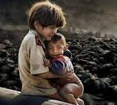

Written by : Noor-ul-ain-khan
ROLL NO : FA25-BDS-039
DATED : 17/09/2025
Submitted to:Mr.Haris
Table of contents
Sr no. | topic
01 | Introduction of poverty
02 | Causes of poverty
03 | Impacts of poverty
04 | Solution of poverty

Introduction:
Poverty in Pakistan is a critical socioeconomic challenge, defined by the inability of a significant portion of the population to access basic human needs such as food, clean water, adequate housing, education, and healthcare. With approximately 40% of its population living below the poverty line, Pakistan faces a severe struggle to provide its citizens with a minimum standard of living. This multidimensional phenomenon, linked to various social and economic factors, destabilizes the nation's fabric and acts as a catalyst for other pressing issues.
Causes of poverty:
The persistence of poverty in Pakistan is attributable to a complex interplay of national and international factors:
Governance and Corruption: Rampant government corruption and a destabilized democracy contribute significantly to poverty by hindering effective resource allocation and development initiatives.
Economic Factors: Uncontrolled inflation, the volatility of the economy, and a lack of investment (both foreign and domestic) create unemployment and economic instability, further pushing people into poverty.
Population Growth: Pakistan's rapidly growing population, with poor households often having more children, strains resources and perpetuates the cycle of poverty, as many children are deprived of education.
Structural Issues: The presence of a feudal system in rural areas restricts land ownership for the poor, while a high dependency on the informal sector for employment provides little security or stability.
Inadequate Social Services: The nation's education and healthcare sectors are underdeveloped, failing to provide essential services, especially to the poor.
Environmental Challenges: Factors like the catastrophic 2022 floods have worsened living conditions and exacerbated poverty for many.
International Factors: Global economic trends, including financial and food crises, have added to Pakistan's internal economic struggles.
Impacts of poverty:
The far-reaching impacts of poverty affect Pakistan's entire socio-economic and political landscape:
Social Instability: Poverty breeds despair, leading to social injustice and a greater propensity for individuals to engage in criminal or terrorist activities.
High Unemployment: The inability of the economy to generate sufficient jobs, especially for the youth, results in widespread unemployment and a lack of economic opportunity.
Health and Education Crisis: Poverty deprives citizens of basic healthcare and education, leading to high rates of learning deprivation and stunting among children.
Reduced Economic Growth: The combination of an unreliable business environment, a heavy state presence in the economy, and a fragile energy sector hinders economic growth and development.
Solution of poverty:
Addressing poverty requires comprehensive and sustained efforts:
Good Governance: Improving administrative systems, ensuring transparency, and reducing corruption are crucial for effective poverty reduction policies.
Investment in Human Capital: Increasing investment in and access to quality education and healthcare services for all citizens is essential for improving living standards and fostering a skilled workforce.
Economic Reforms: Promoting economic stability, fostering a competitive business environment, reforming the tax system to ensure businesses pay fair taxes, and addressing the energy sector's financial unsustainability are vital for growth.
Job Creation: Implementing policies that create both formal and informal sector jobs can provide sustainable livelihoods, particularly for vulnerable populations.
Social Safety Nets: Strengthening social protection programs to provide income security and support for vulnerable groups, including the elderly and those in the informal sector, can offer crucial relief.
Bibiolography and refrencing:
1.Wikipedia
2.world bank
3.Pakistan poverty index
4.shifa foundation
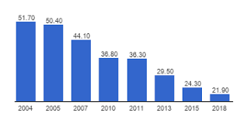
Poverty rate In Pakistan over past years
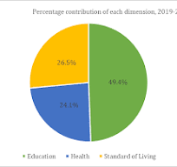
Pie chart showing living standards in Pakistan

